Step 0 Intake + Interview Filing Status, Dependency

Interview Notes: (See also: General Notes)
- The Conways moved from an apartment in Hoboken to an apartment in Jersey City on September 30 of the current tax year. They paid $2,000/month rent in Hoboken through September and $1,000/month in Jersey City starting in October.
- Charles lost his job in August of the current tax year and collected unemployment for the balance of the year.
- In January of the tax year the Conways purchased a 50” LCD TV from Amazon.com and did not pay sales tax on the purchase amount of $1,500.00. The sales tax amount (6.625% in 2018) would have been $99.38
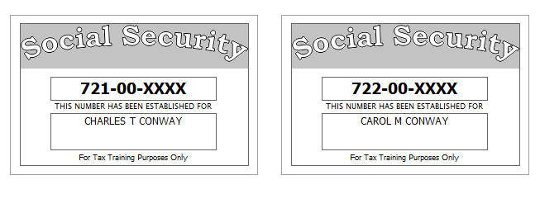

Step 1 Basic Information

TP Form / Note | TS Screen | Notes
SS Card | Start a New 2018 Tax Return  Available Taxpayer Profiles | Ignore the Profiles  Select “Enter Social Security Number” at the bottom of the screen  Enter the TP SSN twice and “Start Return”
Intake Sheet | What is your filing Status? | Answer: Filing Status: Married filing joint  Continue
SS Card  Intake Sheet  G-Note 2 | Personal Information  Taxpayer Information  Spouse Information  Address & Phone Number | TS: Enter all information using “Caps Lock”  Hint: Use Name and SSN from SS card. (Not Intake Sheet)  Hint: SSN format YYY-00-0752  TS: Birth date can be entered using drop down menu or filling in the field.  TS: Check any of the “Check here” questions that apply  - None  TS: Spouses last name auto populates when field is selected. Change if required.  TS: Enter Zip code- TaxSlayer fills in city and state. Correct if required  TS: : New Jersey automatically populates as the Resident State  TS: “Continue”
Intake Sheet  G-Note 2 | New Jersey Return  NJ Property Tax Credit or Deduction  Do you meet Property Tax  Credit or Deduction  Eligibility Requirements?  Taxpayer NJ Health Insurance  Does the Taxpayer have  Health Insurance?  Does the Spouse have  Health Insurance?  New Jersey Return  Select the County or  Municipality of your  current residence | Hint: Begin NJ Checklist  TS Answer: At this point answer “No”. We will go back and adjust after the Federal Return is complete  TS Answer: “Yes”  TS Answer: “Yes  Left click in the box. Type in Hudson. Scroll down to HUDSON COUNTY- JERSEY CITY  At this point just hit ““Continue”” We will go back and adjust after the Federal Return is complete
Intake Sheet. | Dependents/ Qualifying Person(s)  Do you have any Dependents or Qualifying Person(s) to claim on your return? | TS: Answer is “No”.

Federal AGI: 0 Federal Refund: 0 NJ Refund Amount: 0
Step 2 W-2 Vampire Engineering
W-2  Vampire Engineering | Left Menu - Income  Wages & Salaries Form W-2  Complete W-2 Information-  Begin | Hint: This is Charles Conway’s W-2  Hint: Make corrections so that information matches the information on the W-2.  - Correct the address of Employee in the TaxSlayer W-2 to match paper W-2.  - If the name and address of the employer come up after inputting the employer Identification Number, check that the information matcher the paper W-2  Hint: Check boxes 3-7 for correct entries  Hint: Always round up for amounts ending in .50 or enter the cents and TaxSlayer will round off for you.  Hint: Box 12 Use dropdown to select correct code  Hint: Box 13- Retirement Plan should be checked  Hint: Box 14 NJ Codes are selected from drop down menu. All other entries in box 14 are lumped under “Other”.  Hint: If NJ State EIN auto populates, check to be sure it is correct  Hint: Correct NJ wages  Note: The difference between Box 1 and Box 16 is not pre tax medical.  TS: Click Save & Enter Another  TS: NJ warning – Check that the amount in box 16 is correct. If yes.  “ Continue”

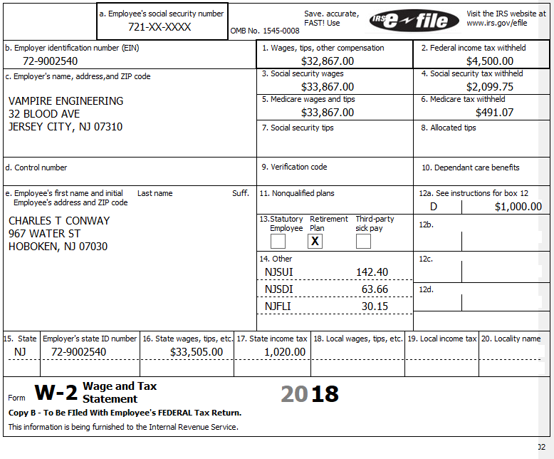

Federal AGI: 32,867 Federal Refund: 4,112 NJ Refund Amount: 538
Step 3 W-2 Smart Kids Charter School

W-2 Smart Kids Charter School | Add W-2 Statement | Hint: This W-2 is for Carol  Hint: Make corrections so that information matches the information on the paper W-2  Hint: If the name and address of the employer come up after inputting the employer Identification Number, check that the information is correct  Hint: Always round up for amounts ending in --.50  Hint: Box 14 NJ Codes are selected from drop down menu. All other entries in box 14 are lumped under “Other”  Hint: If NJ State EIN auto populates, check to be sure it is correct  TS: Click continue  TS: Click Continue

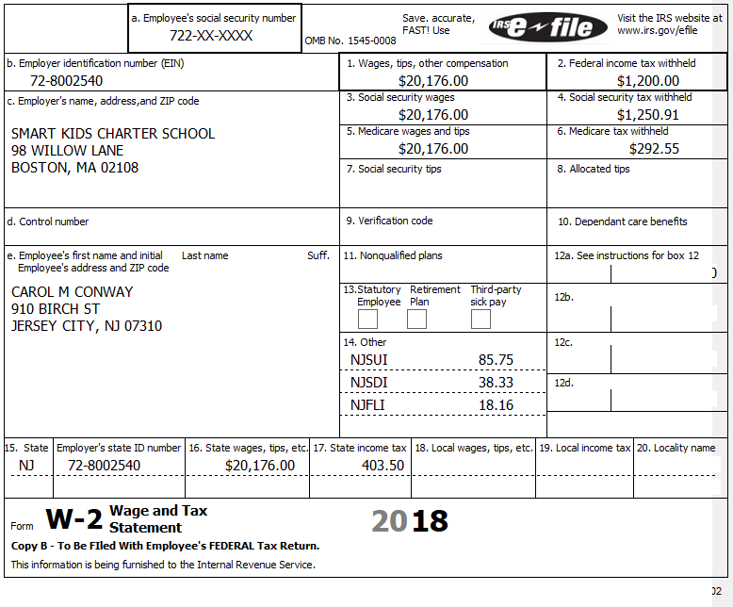

Federal AGI: 53,043 Federal Refund: 2,698 NJ Refund Amount: 578
Step 4 Interest 1099-INT

TP Form / Note | TS Screen | Notes
1099-INT  PNC Bank | Left Menu - Income  Interest and Dividend Income, Form 1099-INT/ 1099-DIV  - Begin  Interest or Dividend Income -Begin  Interest Income, Form 1099-INT  “Continue”” | Hint: Interest is for Taxpayer  Enter values that apply  Hint: It is not required to enter the EIN and address  “Continue”

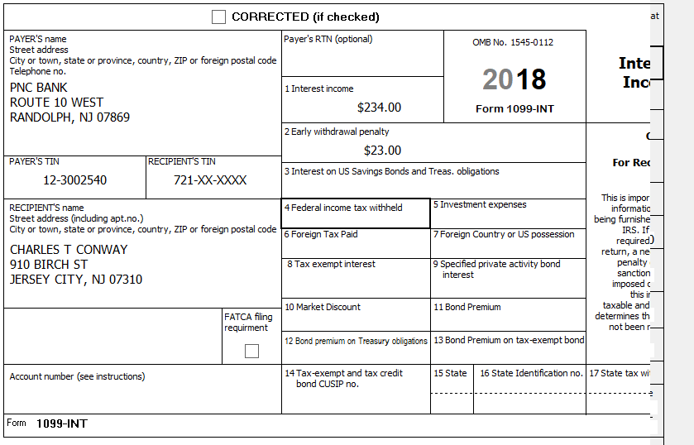

Federal AGI: 53,254 Federal Refund: 2,668 NJ Refund Amount: 573
Step 5 Unemployment 1099-G

TP Form / Note | TS Screen | Notes
1099-G  NJ Dep of Labor | Left Menu- Federal Section - Income  UnemploymentCompensation Form 1099-G Box 1 – Begin  Add or Edit a 1099-G - Begin | TS: This 1099G worksheet is for the: Charles Conway  Hint: Phone number not required  Hint: State information not required  Continue

Charles lost his job in August of the current tax year and collected unemployment for the balance of the year.
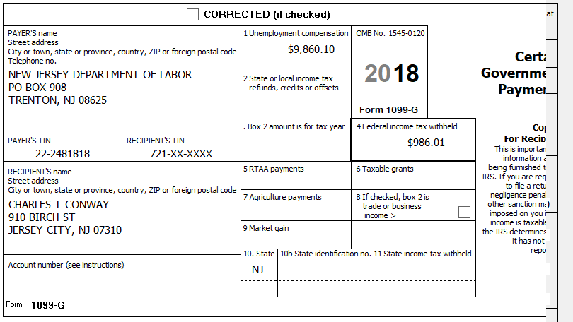

Federal AGI: 63,114 Federal Refund: 2,372 NJ Refund Amount: 573
Step 6 Itemized Deductions – Taxes You Paid
TP Form / Note | TS Screen | Notes
I- Note 1 | Left Menu - Federal Section -Deductions  Enter Myself  Itemized Deductions - Begin  Taxes You Paid - Begin | TS: Go to ADD SALES TAX WORKSHEET and enter ZIP Code and 365 days living in NJ  ““Continue”

Federal AGI: 63,114 Federal Refund: 2,372 NJ Refund Amount: 573
Step 7 Compare Standard vs Itemized Deductions
TP Form / Note | TS Screen | Notes
 | Federal Section  Deductions  Enter Myself  Compare Deductions - Begin | Check to see if using itemized or standard deductions.  Itemized = 1,802  Std = 24,000  Hint: You can view Schedule A (Itemized Deductions) by clicking on the Print Icon next to Itemized Deductions in the Deductions Menu.  Continue

Federal AGI: 63,114 Federal Refund: 2,372 NJ Refund Amount: 573
Step 8 Health Insurance

TP Form / Note | TS Screen | Notes
G-Note 2  Intake Sheet | Left Menu-Health Insurance  Health Insurance Questionnaire  Did you or your family have health insurance or qualify for a coverage exemption at any time in 2018?  Did you purchase insurance via HealthCare.gov of a State Marketplace?  “  Verify Your Household Members  Months Insured  Was your entire household covered by qualifying health care coverage or a coverage exemption that covered 2018 or a combination of qualifying health care coverage and coverage exemptions for every month of 2018? | Answer questions in the Health Insurance Section  TS – Yes  “Continue”  TS – No  “Continue”  TS – Always select ““Continue””  TS-Yes  “Continue”

Every person on the return had health insurance that met Minimum Essential Coverage rules for the entire year. They did not purchase it through the marketplace.

Federal AGI: 63,114 Federal Refund: 2,372 NJ Refund Amount: 573
Step 9 New Jersey Return

TP Form / Note | TS Screen | Notes
I-Note 1 & 3  G-Note 2,3 | State Return –Edit  Basic Information -Edit  Credits - Begin  - ` PropertyTax Credit/Deduction - Begin  Tax -Begin  - Use Tax on Out of State Purchase | Hint: Use the NJ Checklist to enter NJ items  TS: Complete Basic Information  Hint: Gubernatorial Election Fund: Charles and Carol are NO  “SAVE”  Hint: Taxpayer meets Property Tax Eligibility Requirements  Hint: Use scratch pad at TP4F to determine the proper value for Property Tax Paid  - Hint: Property Taxes Paid = (rent*.18)  - [(2000x9)+ (1000x3)]x.18= 3,780  - Taxpayer was not a homeowner in 2018  “SAVE” –“ SAVE”  Hint: Use scratch pad to determine Use tax on TV purchase = $99.38  Save back to the beginning of the State Return
The Conways moved from an apartment in Hoboken to an apartment in Jersey City on September 30 of the current tax year. They paid $2,000/month rent in Hoboken through September and $1,000/month in Jersey City starting in October.
In January of the tax year the Conways purchased a 50” LCD TV from Amazon.com and did not pay sales tax on the purchase amount of $1,500.00. The sales tax amount (6.625% in 2018) would have been $99.38

Federal AGI: 63,114 Federal Refund: 2,372 NJ Refund Amount: 553
Step 10 Prepare for e-file
Intake Sheet  G Note 5 | Left Menu – e-file –  Federal Return Type  Fees  State Return Type  Bank Accounts  Third Party Designee Info  Consent to Disclose  Questions  Taxpayer ID Information | TS – Clear up any diagnostic messages (if any)  TS: Select “E:file: Direct Deposit”  “Next”  TS: No entries in Fees section except for Client email address  “Next”  TS: Select State Refund Type “E:file: Direct Deposit”  “Next”  TS: Enter Bank Information –  - Account Type - Checking  - Name of Bank not required.  - Deposit amount is required. Click “PULL REFUND”  - Enter Routing and Account numbers twice  “ Next”  TS: Skip Third Party Designee. It is Out of Scope for us.  “ Next  TS: Consent to Disclose Tax Return Information – Check GRANT  and enter 5 digit pin (any 5 digit number) and date for TP and SP  Next”  TS – Questions – Answer questions from Intake sheet Part VII, lines 5.6,7 and 8  - Assume taxpayer was present  “Next”  TS: Skip TP ID Information Screen. Not required for NJ.  “SAVE”  You are Done

They want to handle any state refund / amount due like their federal refund / amount due

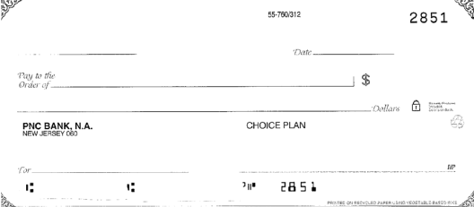
Charles T. & Carol M. Conway
910 Birch Street
Jersey City, NJ 07310
031207607
12345678901

Federal AGI: 63,114 Federal Refund: 2,372 NJ Refund Amount: 553

